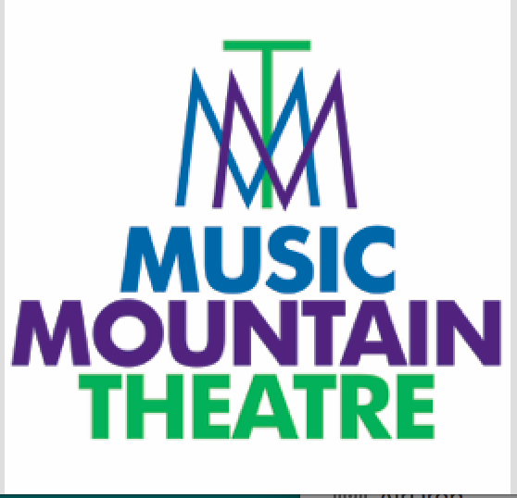

MMT is committed to providing you with high-quality, live entertainment. To that end, per the recommendations of the CDC, American Medical Association, American Pediatrics Association, the Governors of both New Jersey and Pennsylvania, and MMT Board of Directors, all audience members MUST wear a mask in our facility at all times until further notice. We thank you for respecting our policy and look forward to seeing you soon!

Thank you

